Habiba Tabassum
58910
WAD LAB 10



Task # 01
Html:
<!DOCTYPE html>
<html lang="en">
<head>
<meta charset="UTF-8">
<meta name="viewport" content="width=device-width, initial-scale=1.0">
<title>Task1</title>
<style>
.oldClass
{
color: #805152;
font-size: 20px;
font-family:'Times New Roman', Times, serif ;
font-weight: bold
}
.newClass
{
color: #B68384;
font-size: 20px;
font-family:'Times New Roman', Times, serif ; font-weight: bold;
}
</style>
</head>
<body>
<p class="oldClass">Habiba Abbasi</p>
<button onclick="changeClass()">Change Class</button>
<script src="task1.js"></script>
</body>
</html>

JS:
function changeClass() {
let element = document.querySelector(".oldClass");
console.log("Old class name:", element.className);
element.className = "newClass";
element.textContent = "I am doing CS";
console.log("New class name:", element.className);
}

Output:
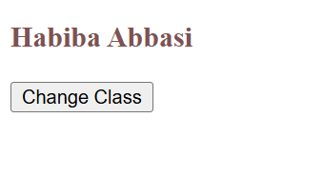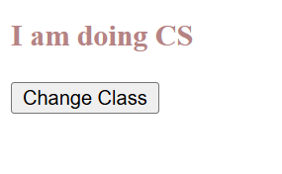

Task # 02
Html:
<!DOCTYPE html>
<html>
<head>
<title>Task2</title>
</head>
<body>
<p>Hello!!!</p>
<script src="task2.js"></script>
</body>
</html>
JS:
let btn = document.createElement("button");
btn.textContent = "log In";
btn.style.color = "black";
btn.style.backgroundColor = "green";
document.documentElement.insertBefore(btn, document.body);

output:
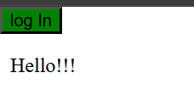
Task # 03
Html:
<!DOCTYPE html>
<html lang="en">
<head>
<meta charset="UTF-8">
<meta name="viewport" content="width=device-width, initial-scale=1.0">
<title>Task3</title>
<style>
.firstClass
{
color: #805152;
font-size: 18px;
}
.secondClass
{
background-color: #B68384;
font-weight: bold;
border: 2px solid #bdc4d4;
padding: 5px;
}
</style>
</head>
<body>
<p class="firstClass" id="my">Habiba</p>
<button onclick="addNewClass()">new style</button>
<script src="task3.js"></script>
</body>
</html>
Js:
function addNewClass()
{
let para = document.getElementById("my");
const style = document.createElement("style");
style.innerHTML = `
.secondClass
{
background-color: pink;
font-weight: bold;
border: 2px solid black;
padding: 5px;
}`;
document.head.append(style);
para.classList.add("secondClass");
console.log("New class added!");
}

Output:
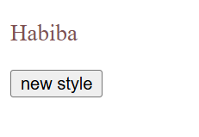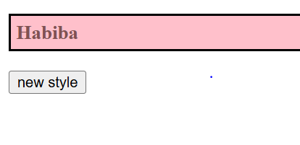

Task # 04
Html:
<!DOCTYPE html>
<html lang="en">
<head>
<meta charset="UTF-8">
<meta name="viewport" content="width=device-width, initial-scale=1.0">
<title>Task4</title>
</head>
<body style="text-align:center; margin-top:50px;">
<h2> Click the bulb to turn it ON or OFF</h2>
<img id="bulbImage" src="/Images/off.jpg"
alt="Bulb"
style="width:150px; cursor:pointer;"
onclick="toggleBulb()">
<script src="task4.js"></script>
</body>
</html>
Js:
function toggleBulb()
{
let bulb = document.getElementById("bulbImage");
if (bulb.src.includes("bulboff"))
{
bulb.src = "/Images/off.jpg";
}
else
{
bulb.src = "/Images/on.jpg";
}
}

Output:
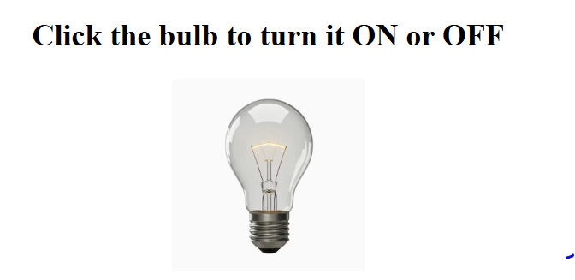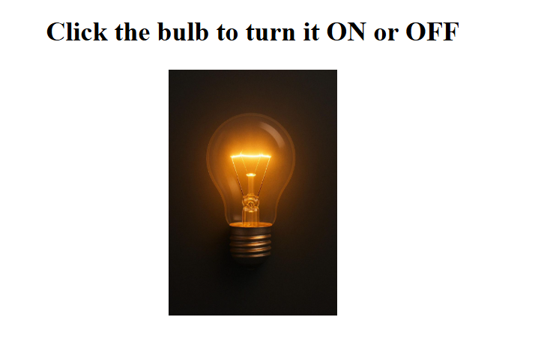

TASK # 05
Html:
<!DOCTYPE html>
<html lang="en">
<head>
<meta charset="UTF-8">
<meta name="viewport" content="width=device-width, initial-scale=1.0">
<title>Task5</title>
<style>
p {
font-size: 20px;
color: rgba(255, 14, 70, 0.854);
}
</style>
</head>
<body>
<p id="myPara">Hello! My name is Habiba</p>
<button onclick="toggleParagraph()">Hide / Show</button>
<script src="task5.js"></script>
</body>
</html>
Js:
function toggleParagraph()
{
let para = document.getElementById("myPara");
if (para.style.display === "none")
{
para.style.display = "block";
}
else
{
para.style.display = "none";
}
}

Output:
